DEPARTMENT OF COMPUTER SCIENCE AND ENGINEERING
SUBJECT CODE: 19CS2109
COMPUTER NETWORKS AND SECURITY

ROUTING ALGORITHMS#4
Date of the Session: ___/___/___ Time of the Session: _____to______

Learning out comes:
● To understand ROUTING ALGORITHMS working principle.
● To understand and apply Dijkstra’s and Distance Vector Routing algorithms.

IN-TUTORIAL:

- Given below is a network. They are connected with links having weights as shown below:
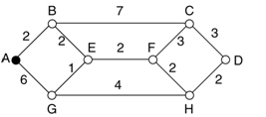

In the above Subnet try to find all possible paths from Node A using Dijkstra’s (Shortest Path) routing algorithm.

Solution:

- a) Explain about Count to Infinity problem in Distance Vector routing algorithm with a simple example.
b) Construct Link State Packets for all the six routers shown in the following figure.
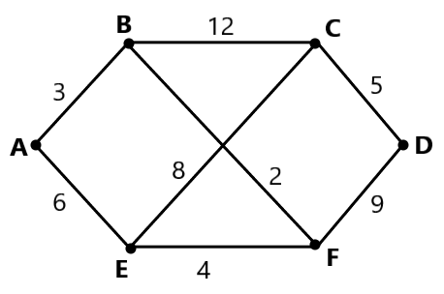
Solution:

.

- In the network shown below, assume that initially each node knows the cost to each of it’s neighbours. Consider the distance vector algorithm and illustrate the distance table entry at node z at each step of the algorithm.

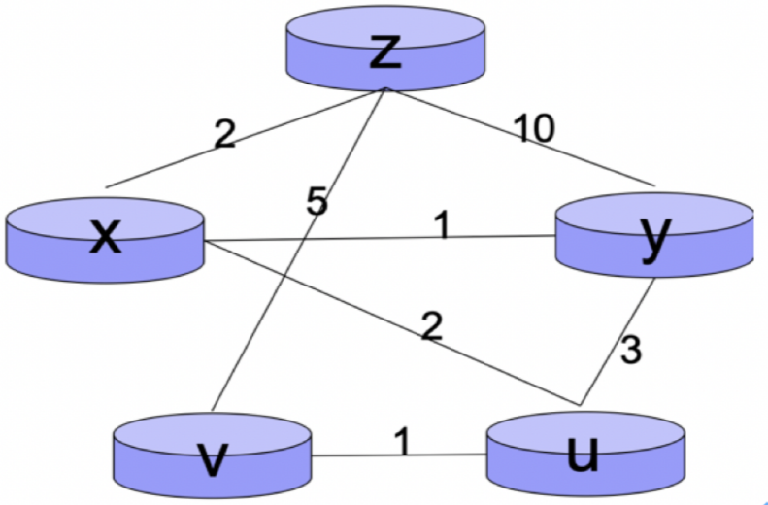

Solution:

POST-TUTORIAL:

1. For the network shown below
a) Construct a Routing table at node B (using Dijkstra’s Algorithm). Table should consist of three columns:

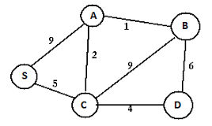
Destination, Cost, NextHop.

Solution:

- For the network shown below, build a routing table for node A using the Hierarchical Routing Algorithm. ( Note Assume Region-1 as : B,A,C and Region-2 as D,E,F,G)

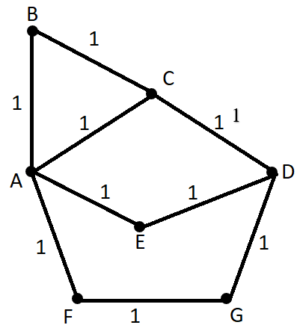

Solution:

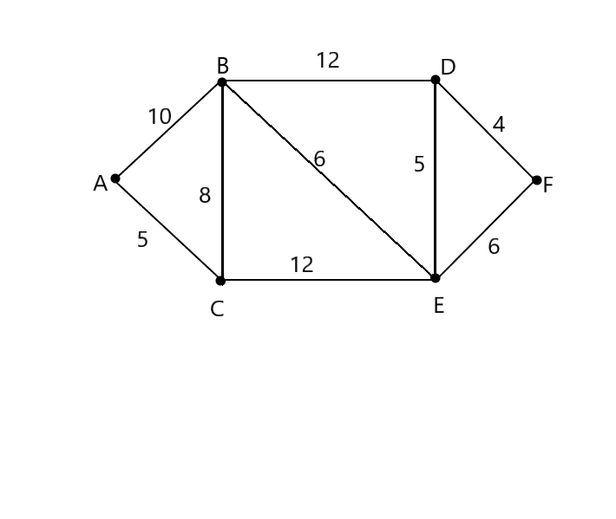
- Find the shortest path near A to all other nodes for the following network of routers using Dijkstra’s shortest path algorithm

Solution:

- Develop a Menu Driven Python Program in finding the shortest distance to all vertices from a source vertex in a weighted graph using Dijkstra’s Algorithm as per the given conditions.
Menu must contain:
- Adding vertex to the graph taking argument as vertex name
- Adding edge to the graph taking arguments source vertex – destination
vertex- edge cost
- Shortest distance from given source as argument to remaining vertices
- Display all the edge from source to destination with their weights
- Quit from the finding shortest path

Solution:

(For Evaluator’s use only)
Comment of the Evaluator (if Any)

Evaluator’s Observation
Marks Secured: _______ out of ________

Full Name of the Evaluator:

Signature of the Evaluator Date of Evaluation:

POST-TUTORIAL:

- Write a Menu driven program to generate hamming code for the given data that is given and if any hamming code is given, you have to check the errors in the code and display the bit option=int (input('Press 1 for generating hamming code in Press 2 for finding error in hamming code\n\t Enter your choice:--\n'))

Solution:

- a) Data of 25 bits is arranged in 5X5 matrix (rows r0 to r4 and columns d5 to d1) and is padded with column d0 and row r5 of parity bits computed using odd party scheme. Each bit of column d0 (respectively row r5) gives the parity of the corresponding row (respectively, column). These 36 bits are transmitted over the data link.

 | D5 | D4 | D3 | D2 | D1 | D0
R0 | 1 | 1 | 0 | 0 | 1 | 0
R1 | 1 | 0 | 1 | 1 | 1 | 0
R2 | 1 | 1 | 1 | 0 | 0 | 1
R3 | 0 | 0 | 1 | 0 | 0 | 0
R4 | 0 | 1 | 1 | 1 | 0 | 0
R5 | 0 | 0 | 0 | 1 | 0 | 0

Check the above table and find the errors, if any. Write down the minimum possible number of corrupted bits.

b) Five packets of data, each packet containing 7 bits to be transmitted over the internet using the even parity. Append the parity bits using 2D parity with even parity, append all the parity bits to this following data.
Given data is
Frame1: 1011101
Frame2: 1110111
Frame3: 1010101
Frame4: 1111011
Frame4: 1100001

Solution:

(For Evaluator’s use only)
Comment of the Evaluator (if Any)

Evaluator’s Observation
Marks Secured: _______ out of ________

Full Name of the Evaluator:

Signature of the Evaluator Date of Evaluation:

